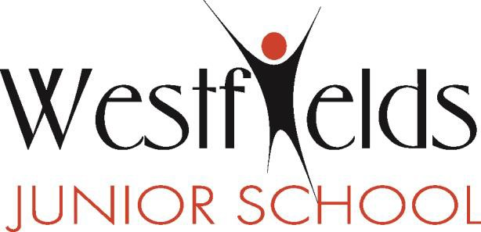
School Lane, Yateley, Hampshire, GU46 6NN
Tel: (01252) 408218 Fax: (01252) 408216
Headteacher: Miss J Redman
www.westfields-jun.hants.sch.uk
@westfields_jun

UNITE - INSPIRE - EXCEL

10th January 2020
Dear Parents,
At Westfields Junior School, we produce ‘Attainment and Progress Trackers’ which inform you of your child’s current attainment and how ‘on track’ they are in achieving the end of year expectations for their year group. This tracker also gives you the personalised key targets that your child will be working on in class over the next half term.

Today, you will receive via ‘pupil post’ your child’s tracker which was completed by their class teacher to show their end of autumn term attainment and progress towards end of year expectations. Key targets set previously have been reviewed and updated where necessary.

As before, the summaries include the following information:

- An indication of your child’s current attainment against the end of year expectations for their year group.
You will be able to see the judgement made at the end of the autumn term for the areas of reading, writing and maths. It is important to note that at this point, we are only a third of the way into the academic year, having taught around a third of the curriculum so most children will be ‘working towards’ achieving end of year expectations. This means they are currently accessing the learning in their year group and making progress. There will be some children who are still requiring significant additional support as they are working below year group expectations. In addition to this, there will also be some children who are consistently achieving objectives to a high standard, demonstrating breadth of knowledge across the areas we assess against so therefore will be close to meeting the end of year expectations.

- An indication of how ‘on track’ your child is to meet the expectations by the end of the year.
This judgement shows whether your child is currently not on track to meet end of year expectations for their year group, on track to meet or on track to achieve a greater depth. Please note, that as the year progresses, this can change because children learn and progress at different rates. This current indication is based on your child’s learning on a daily basis together with assessments of what they have learnt and understood so far during this year. If your child is currently not on track to meet, they will be receiving additional support in the form of extra time with the teacher or support staff in and out of the classroom or through weekly intervention groups. Any additional support at home would be beneficial and if you would like further information as to how best to support your child, please see their class teacher.

- Current key targets
In order to clarify what the children’s individual next steps are, one or two targets have been identified, taken from key areas of learning for reading, writing and maths. We hope that this information will enable you to support your child further at home.

The intention of providing this information is not only to continue to keep you informed of the progress your child is making but also support us to work in partnership with you to encourage them towards future success and achieve their full potential. As ever, if you require any further detail or clarification, please do ask your child’s class teacher or year group team leader.

Yours sincerely,

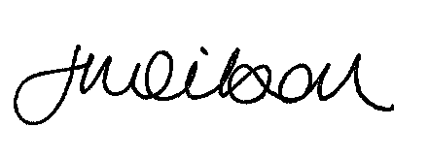

Mrs Jo Wilson
Deputy Headteacher and Assessment Coordinator

